RESUME 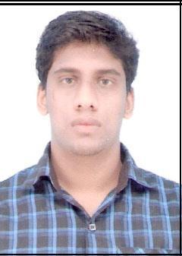
SHIJU.P
Lakshmi nivas
Aduthila east,p.o.payangadi Mob – 9633911566
Kannur, Kerala – 670303 E-mail ID: shijuvasanthan@gmail.com

OBJECTIVES
To get a fine opening to exploit and develop my capabilities through a reputable institution which will be an ideal platform for the fullest use and development of my potential to perfect.

EDUCATIONAL QUALIFICATION

- SSLC ( from the year of 2005 to 2007)
- Plus Two (from the year of 2008 to 2009)
- B.com ( from the year of 2010 to 2012)

COMPUTER KNOWLEDGE

- MS. Office &Tally , internet , web

WORKING EXPERINECE

- Worked in Hdfc Bank Ltd as credit card sales executive in sub contract basis at Hbl Global Pvt Ltd about 7 months from the date of 17th may 2013 to 15th december 2013.
- Worked in Yes Bank Ltd as Client Relationship Partner about one year and one week from the date of 26th December 2013 to 2nd january 2015.

PERSONAL INFORMATION
Name : SHIJU.P
Father’s Name : VASANTHAN.P
Address : LAKSHMI NIVAS
ADUTHILA EAST
P.O.PAYANGADI
KANNUR (DT), KERALA (ST) – 670303
Mobile Number : 9633911566
Nationality : INDIAN
Sex : MALE
Date of Birth : 30-8-1992
Marital Status : SINGLE
Religion & Caste : HINDU,THIYYA
Languages Known : ENGLISH, HINDI & MALAYALAM

PASSPORT DETAILS
Passport Number : k5216800
Place of Issue : Kozhikode
Date of Issue : 13/07/2012
Date of Expiry : 12/07/2022

DECLARATION
I hereby certify that the above information furnished by me is true and correct to the best of my knowledge and belief.

Place: PAYANGADI
Date: SHIJU.P

